**Employee Hiring Software to Prevent Favoritism**

**STATE DIAGRAM :**   
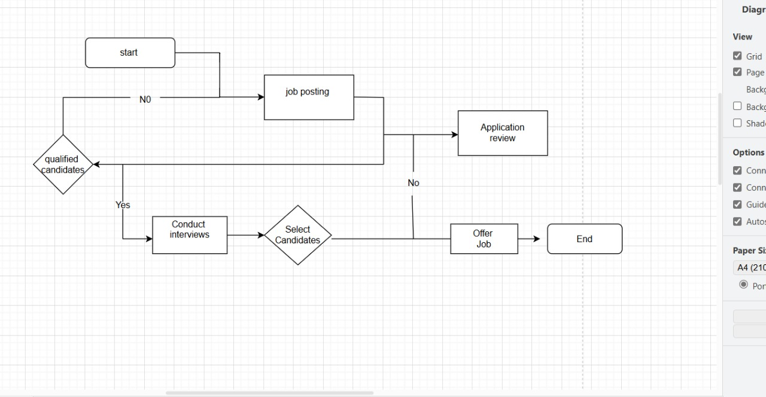

**ERD DIAGRAM :**

